**ARTICLE TITLE**

**Abstract:** Articles should be in Microsoft Word format and the word count should not exceed the word count determined according to the article type under the Information for Authors heading on the website. Page margins: top, bottom, left and right should be 2.5 cm (Normal Margins). The title of the article should be written in all capital letters, bold letters, Cambria, 11 pt, 1.3 line spacing, with automatic before and 8 nk after spacing and centered on the page. The abstract should be between 200-250 words. An abstract is usually presented separately from the article, so it should be able to stand on its own. It is recommended that the abstract is written in a structured way. "**Aim:** ..... **Method:** ..... **Results:** ..... **Conclusion:** ....." can be given as an example. The abstract should be written in Cambria, 10 pt. font size, with automatic before and 8 nk. after spacing and justified. References should be avoided in the abstract, but if necessary, cite the author(s) and year(s). Also, non-standard or uncommon abbreviations should be avoided, but if necessary, they should be defined at the first occurrence in the abstract. Keywords should not exceed a minimum of 3 and a maximum of 7 words. Keywords should be capitalized and separated by commas. In addition, should be typed in Cambria 10 pt. font size, auto-spaced before and 8 nk. after, and left-aligned.

**Keywords:** Keyword 1, Keyword 2, Keyword 3

**ARTICLE TITLE IN TURKISH**

**Öz:** Makaleler; Microsoft Word formatında olmalı, kelime sayısı sitede yer alan Yazarlara Bilgi başlığı altındaki makale türüne göre belirlenen kelime sayılarını geçmemelidir. Sayfa kenar boşlukları: üst 4 cm, alt, sol ve sağ 2,5 cm olmalıdır. Makale başlığı bütün harfleri büyük, koyu (bold) harflerle, Cambria, 11 punto, 1.3 satır aralıklı, öncesi Otomatik ve sonrası 8 nk aralıklı ve sayfaya ortalanarak yazılmalıdır. Özet 200-250 kelime arasında olmalıdır. Bir özet genellikle makaleden ayrı olarak sunulur, bu nedenle tek başına ayakta durabilmelidir. Özetin yapılı bir şekilde yazılmış olması önerilmektedir. “**Amaç:** ….. **Yöntem:** ..... **Bulgular:** ….. **Sonuç:** …..“ şeklinde bir örnek verilebilir. Özet Cambria, 10 punto, öncesi Otomatik ve sonrası 8 nk aralıklı ve yaslı yazılmalıdır. Özet içerisinde kaynaklara atıf yapmaktan kaçınılmalı, ancak gerekliyse yazar(lar)ı ve yıl(lar)ı belirtiniz. Ayrıca, standart olmayan veya yaygın olmayan kısaltmalardan kaçınılmalıdır, ancak gerekliyse özette ilk geçtiği yerde tanımlanmalıdır. Anahtar kelimeler asgari 3 ve en fazla 7 kelimeyi aşmamalıdır. Anahtar kelimelerin baş harfleri büyük olmalı ve virgül ile ayrılmalıdır. Ayrıca Cambria, 10 punto, öncesi Otomatik ve sonrası 8 nk aralıklı ve sola hizalı yazılmalıdır.

**Anahtar Kelimeler:** Anahtar Kelime 1, Anahtar Kelime 2, Anahtar Kelime 3

**INTRODUCTION**

Articles should be in Microsoft Word format and the word count should not exceed the word count determined according to the article type under the Information for Authors heading on the website. Page margins: top 4 cm, bottom, left and right 2.5 cm. Also, line spacing should be 1.3.

The main text should be written in Cambria typeface in 11 pt, preceded by Auto and followed by 8 nk and justified.

The main headings of the article should be written in all capital letters, using Cambria font, in 11 pt, single-spaced, before Automatic and after 8 nk and justified. Subheadings, on the other hand, should be written with only the first letter capitalized, using Cambria typeface, in 11-point font, before Automatic and after 8 nk and justified. If a third subheading is used, it should be in 11 pt, italicized, normal (not bold), before Auto and after 8 nk, justified and only the first letter of the words in the heading should be capitalized. There should be no spaces before or after the headings. As few headings as possible should be used and mixed numbering should be avoided.

**Theoretical Framework**

Compliance of the study with the specified rules will speed up the publication process. For this reason, the study must be made in accordance with the rules of the journal before submission. Articles uploaded to the journal's article management system should not have the name(s) of the author(s). Because the information of the users registered to the system is available online and this information will also be included on the cover page.

The similarity rate of the articles submitted to the journal should not exceed 20% excluding references. For research requiring ethics committee approval, ethics committee approval must be obtained and documented. The ethics committee approval document must be uploaded to the system as an additional file. Institutional approval should also be added when required.

**OBJECTIVE**

Titles written in all capital letters should not be replaced. If there is an abstract of the literature, it should be included in the first title. The main headings are as follows:

**INTRODUCTION**

**OBJECTIVE**

**METHODS**

**RESULTS**

**CONCLUSION**

However, the author may add subheadings or main headings such as DISCUSSION as deemed necessary.

In-text citation method should be used in articles. In the citation, the surname of the author(s) and the year of publication should be in parentheses. If the surname of the author(s) is used in the sentence, include the date of publication in parentheses after the name.

When citing studies with two authors, the surnames of both authors should be written. For studies with three or more authors, the surname of the first author should be written and the expression "et al." should be used.

If more than one work of the author(s) published in the same year is cited, the sources should be separated from each other by writing symbols such as "a, b, c" at the end of the publication year. If more than one work is cited at the end of a sentence, these references should be given in parentheses and a semicolon (;) should be placed between them.

In-text citation should be created within the scope of the examples given below. Citing the source in the text:

Single author (Yılmaz, 2017).

Two authors (Mehmet & Ali, 2019).

Three or more authors (Taş et al., 2016a).

The use of programs for resource management is recommended (Mendeley, Zotero, Endnote, etc.).

**SCOPE**

All tables, figures and graphs to be included in the text of the article should be numbered in sequence (Table 1, Figure 1).

Titles should be written above the tables, below the figures and graphs, centered, bold, and only the initials of the words should be capitalized. The font size in tables can be determined according to need (e.g. 9 pt.).

The references, if any, of tables, figures and graphs should be given immediately below them in accordance with the in-text citation rules. One line space should be left between tables and figures and the text. Prepared tables should be editable and suitable for Word format.

**Table 1. Evaluation of Study Parameters According to Groups**

|  |  |  |  |  |  |
| --- | --- | --- | --- | --- | --- |
|  | **Body Mass Index** | | | **χ2-KW, F** | **p** |
| **Normal** | **Overweight** | **Obese** |
| **Group I** | **Group II** | **Group III** |
| **Mean±SD (median)** | **Mean±SD (median)** | **Mean±SD (median)** |
| **Duration of Diabetes** | 2,85±1,33 (2) | 3,65±1,23 (4) | 3,78±1,28 (4) | **KW:14,659** | **30,001\*\*** |
| **HbA1c** | 6,6±0,97 | 8,24±1,67 | 10,27±1,76 | **F:76,203** | **20,001\*\*** |
| **Glucose (mg/dl)** | 115,94±38,32 | 163,6±47,4 | 298,78±93,01 | **F:110,614** | **20,001\*\*** |
| **Cholesterol** | 170,32±24,95 | 207,55±39,24 | 267,6±53,44 | **F:73,724** | **20,001\*\*** |
| **Triglyceride** | 107,94±54,21 | 146,92±68,29 | 252,68±86,69 | **F:56,556** | **20,001\*\*** |
| **HDL** | 50,77±11,31 | 50,42±11,08 | 40,84±7,23 | **F:15,738** | **20,001\*\*** |
| **LDL** | 97,8±18,73 | 127,75±35,66 | 173,23±49,99 | **F:53,869** | **20,001\*\*** |

1*Chi-Squared Test 2One-Way ANOVA 3Kruskal-Wallis Test **p<0.01*

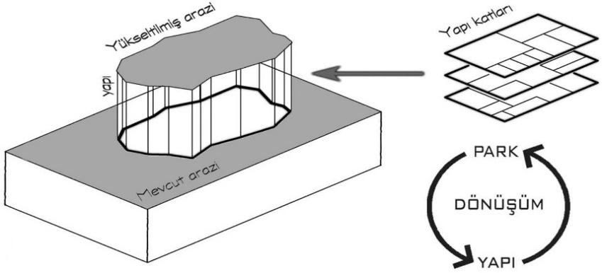

**Graphic 1.** Sample Graphic Text

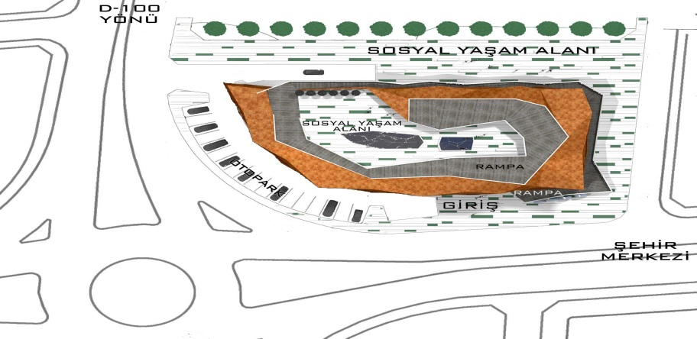

**Figure 1.** Sample Figure Text

**METHODS**

Lorem ipsum dolor sit amet, consectetur adipiscing elit, sed do eiusmod tempor incididunt ut labore et dolore magna aliqua. Id porta nibh venenatis cras sed felis eget velit. Eu scelerisque felis imperdiet proin. Tortor condimentum lacinia quis vel eros donec ac odio tempor. Mi bibendum neque egestas congue quisque egestas diam in. Lacus vel facilisis volutpat est velit egestas dui id ornare. Nisl suscipit adipiscing bibendum est ultricies integer. Facilisi nullam vehicula ipsum a arcu cursus vitae congue mauris. Venenatis tellus in metus vulputate eu. Posuere urna nec tincidunt praesent semper feugiat nibh sed. Cursus sit amet dictum sit amet justo donec enim diam. Tristique senectus et netus et malesuada. Auctor urna nunc id cursus metus aliquam eleifend. Sit amet justo donec enim diam vulputate ut. Vitae sapien pellentesque habitant morbi tristique senectus et netus et. Ut porttitor leo a diam sollicitudin tempor id eu nisl.

**Research Limitations**

Ac placerat vestibulum lectus mauris. Viverra tellus in hac habitasse platea dictumst vestibulum rhoncus. Posuere lorem ipsum dolor sit amet consectetur. Ut venenatis tellus in metus. Dictum at tempor commodo ullamcorper. Sed id semper risus in hendrerit gravida rutrum quisque. Aliquam etiam erat velit scelerisque in dictum non consectetur a. Risus nec feugiat in fermentum. Blandit cursus risus at ultrices mi. Lectus mauris ultrices eros in. Augue eget arcu dictum varius duis at. Cras pulvinar mattis nunc sed blandit libero volutpat. Eget velit aliquet sagittis id consectetur purus. Venenatis a condimentum vitae sapien pellentesque habitant. Id faucibus nisl tincidunt eget nullam non nisi. In nibh mauris cursus mattis. Sed egestas egestas fringilla phasellus faucibus scelerisque. Arcu risus quis varius quam. Ullamcorper eget nulla facilisi etiam dignissim diam quis enim lobortis. Tellus id interdum velit laoreet.

**Research Problem**

Neque egestas congue quisque egestas diam in arcu cursus. Sit amet tellus cras adipiscing enim eu turpis egestas pretium. Praesent elementum facilisis leo vel fringilla est ullamcorper eget nulla. Ac feugiat sed lectus vestibulum mattis ullamcorper. Volutpat diam ut venenatis tellus in metus vulputate eu scelerisque. Mattis aliquam faucibus purus in massa tempor nec feugiat nisl. Et malesuada fames ac turpis egestas maecenas pharetra convallis. Hac habitasse platea dictumst vestibulum rhoncus. Et molestie ac feugiat sed lectus. Blandit libero volutpat sed cras ornare arcu. Sapien nec sagittis aliquam malesuada bibendum arcu. Lectus vestibulum mattis ullamcorper velit sed ullamcorper morbi. Amet nisl purus in mollis nunc sed id. At imperdiet dui accumsan sit amet nulla facilisi morbi tempus. Et ligula ullamcorper malesuada proin libero nunc. Convallis aenean et tortor at risus viverra adipiscing at in. Vulputate enim nulla aliquet porttitor.

***Sub Problems of the Research***

Dignissim suspendisse in est ante in nibh. Sit amet consectetur adipiscing elit. Potenti nullam ac tortor vitae purus faucibus ornare suspendisse. Fringilla est ullamcorper eget nulla. Sodales ut etiam sit amet nisl. Consequat interdum varius sit amet. Placerat in egestas erat imperdiet sed euismod nisi porta. Malesuada proin libero nunc consequat. At urna condimentum mattis pellentesque id nibh tortor id aliquet. Curabitur gravida arcu ac tortor dignissim convallis aenean et. Cras fermentum odio eu feugiat pretium nibh ipsum. Consectetur adipiscing elit ut aliquam purus sit amet luctus.

**Research Hypotheses**

Etiam sit amet nisl purus in mollis. Cursus risus at ultrices mi tempus imperdiet. Feugiat in ante metus dictum. Non tellus orci ac auctor augue mauris augue neque gravida. Ultricies integer quis auctor elit sed vulputate mi sit amet. In est ante in nibh mauris. Suspendisse ultrices gravida dictum fusce. Ac feugiat sed lectus vestibulum mattis ullamcorper velit. Pretium quam vulputate dignissim suspendisse in. Auctor urna nunc id cursus metus aliquam eleifend mi.

**RESULTS**

Dignissim sodales ut eu sem integer vitae justo eget. Amet consectetur adipiscing elit ut aliquam. In hendrerit gravida rutrum quisque. Turpis nunc eget lorem dolor sed viverra ipsum nunc. At ultrices mi tempus imperdiet nulla malesuada. Eu mi bibendum neque egestas congue quisque egestas. Vestibulum sed arcu non odio euismod lacinia. Elit ut aliquam purus sit. Posuere urna nec tincidunt praesent semper feugiat nibh sed. Sit amet luctus venenatis lectus magna fringilla urna. Duis convallis convallis tellus id interdum velit laoreet id. Consequat mauris nunc congue nisi. At tempor commodo ullamcorper a lacus vestibulum sed arcu non.

**DISCUSSION**

Turpis in eu mi bibendum neque egestas congue. Neque sodales ut etiam sit amet nisl purus in. Sed turpis tincidunt id aliquet risus feugiat in ante. Nisi quis eleifend quam adipiscing vitae proin sagittis nisl. Gravida neque convallis a cras semper auctor neque. Venenatis tellus in metus vulputate eu scelerisque. Dictum varius duis at consectetur lorem donec. Gravida cum sociis natoque penatibus et magnis dis parturient. Penatibus et magnis dis parturient montes nascetur ridiculus mus. Posuere morbi leo urna molestie at elementum. Sit amet mattis vulputate enim. Diam vulputate ut pharetra sit amet aliquam id diam. Pulvinar sapien et ligula ullamcorper malesuada proin libero. In aliquam sem fringilla ut.

**CONCLUSION**

Fringilla ut morbi tincidunt augue interdum velit euismod in. Elementum curabitur vitae nunc sed velit dignissim sodales ut. Tellus in metus vulputate eu scelerisque felis imperdiet proin. Adipiscing tristique risus nec feugiat. Pulvinar sapien et ligula ullamcorper malesuada proin libero nunc. Purus ut faucibus pulvinar elementum integer enim neque volutpat. Tristique et egestas quis ipsum suspendisse. Sit amet purus gravida quis blandit turpis cursus in. Ornare massa eget egestas purus viverra accumsan in nisl. Purus semper eget duis at tellus. Egestas tellus rutrum tellus pellentesque eu tincidunt tortor. Aliquam eleifend mi in nulla posuere sollicitudin. Ligula ullamcorper malesuada proin libero nunc. In ante metus dictum at tempor commodo.

**SUGGESTIONS**

Vivamus arcu felis bibendum ut. Ut placerat orci nulla pellentesque dignissim enim. At tellus at urna condimentum mattis pellentesque. Suspendisse faucibus interdum posuere lorem ipsum dolor sit amet. Sed augue lacus viverra vitae congue eu consequat. Augue eget arcu dictum varius duis at consectetur lorem. Commodo nulla facilisi nullam vehicula ipsum a arcu cursus. Consectetur adipiscing elit pellentesque habitant morbi tristique senectus et. Nisi est sit amet facilisis magna. Viverra vitae congue eu consequat ac felis donec et. Consectetur a erat nam at. Amet nisl purus in mollis nunc sed id semper risus. Eu augue ut lectus arcu bibendum. Ut tellus elementum sagittis vitae et leo duis ut diam. Facilisi etiam dignissim diam quis enim lobortis scelerisque.

**REFERENCES**

**References Writing Method**

Our journal uses APA 7 reference style. For more information, please see the Publication Manual of the American Psychological Association, Seventh Edition, ISBN 978-1-4338-3215-4 or visit the APA Style website.

In the list of references, only the references cited in the article should be included and these references should be listed alphabetically according to the surname of the author. If several works of one author are to be included in the bibliography, they should be sorted according to the publication date (from old to new). If more than one work of the author(s) with the same date is cited, the references should be listed by using the letters (a, b, c, ...) after the publication date in the bibliography section as in the text.

If the number of authors in the article is 20 or less, all authors should be indicated; if the number of authors is 21 or more, the first 19 names should be written and the last author should be added after adding the phrase "..." (without adding &).

Articles on the internet whose author is unknown should not be cited as a source.

In the case of citing an author's work with single or multiple authors, single-author works should be written first. Page numbers of articles published in journals and chapters in edited books must be written.

It is recommended to use reference management programs (Mendeley, Zotero, Endnote, etc.) for integrity and editability.

**Examples**

**Reference to a book:**

Strunk, W., Jr., & White, E. B. (2000). *The elements of style* (4th ed.). Longman (Chapter 4).

**Reference to a chapter in an edited book:**

Mettam, G. R., & Adams, L. B. (2009). How to prepare an electronic version of your article. In B. S. Jones, & R. Z. Smith (Eds.), *Introduction to the electronic age* (pp. 281–304). E-Publishing Inc.

**Reference to a journal publication:**

Van der Geer, J., Hanraads, J. A. J., & Lupton, R. A. (2010). The art of writing a scientific article. *Journal of Scientific Communications*, 163, 51–59. https://doi.org/10.1016/j.sc.2010.00372

**Reference to a journal publication with an article number:**

Van der Geer, J., Hanraads, J. A. J., & Lupton, R. A. (2018). The art of writing a scientific article. *Heliyon*, 19, Article e00205. https://doi.org/10.1016/j.heliyon.2018.e00205

**Reference to a website:**

Powertech Systems. (2015). *Lithium-ion vs lead-acid cost analysis*. Retrieved from http://www.powertechsystems.eu/home/tech-corner/lithium-ion-vs-lead-acid-cost-analysis/. Accessed January 6, 2016

**Reference to a dataset:**

[dataset] Oguro, M., Imahiro, S., Saito, S., & Nakashizuka, T. (2015). *Mortality data for Japanese oak wilt disease and surrounding forest compositions*. Mendeley Data, v1. <https://doi.org/10.17632/xwj98nb39r.1>

**Reference to a conference paper or poster presentation:**

Engle, E. K., Cash, T. F., & Jarry, J. L. (2009, November 19-22). *The Body Image Behaviours Inventory-3: Development and validation of the Body Image Compulsive Actions and Body Image Avoidance Scales* [Poster presentation]. Association for Behavioural and Cognitive Therapies Annual Convention, New York, NY.

**Reference to software:**

Coon, E., Berndt, M., Jan, A., Svyatsky, D., Atchley, A., Kikinzon, E., Harp, D., Manzini, G., Shelef, E., Lipnikov, K., Garimella, R., Xu, C., Moulton, D., Karra, S., Painter, S., Jafarov, E., & Molins, S. (2020, March 25). *Advanced Terrestrial Simulator (ATS) v0.88 (Version 0.88)*. Zenodo. https://doi.org/10.5281/zenodo.3727209.